DRAFT 8/06/2020
Building:
- Limited entry into school. Parents encouraged to call, email, facetime office. Sign posted.
- Volunteering will be reduced.
- All those who enter will wear masks.
- All those who enter will be health and temperature screened. (please see health screening form)
- No all school gatherings.
- Virtual parent conferences.
- Tables set up in gym for teacher meetings, teacher prep times, teacher lunch; to allow for social distancing. ¼ sectioned off with large dividers.
- This is our new staff room. Students eat in classrooms or outside and have PE outside, weather permitting.
- Another ¼ of gym sectioned off to place students waiting to go home due to illness, in a Recovery Area. Large dividers are put up, students put in opposing corners while they wait for parents.
- Student and staff hygiene will be emphasized. Hand sanitizer stations in each classroom.
Classroom:
- Students desks will be 6 feet apart and students will rotate for learning less.
- Student tables will have clear plastic dividers between students.
- All student manipulatives that cannot be easily cleaned will be removed.
- Students will wear masks.
- Classroom masses in one grade a week, if approved by Bishop.
- Teachers will take a picture of where students are sitting each morning to establish contact tracing.
- Couches will be moved out of classrooms to allow for spreading out desks, we will move them into the Recovery Area in the gym.
Drop off /Pick Up
No students with a temperature above 100.00 will remain at school, please note this is lower than the recommended 100.4 in order to decrease the chances of illness spread.
Health Screening Tickets
We will create small forms that ask health screening question that the health department wants us to ask. We hope that parents fill them out quickly before drop off and one student in the family can hand them to staff as they enter the building. The health department is encouraging families to keep students home if they have one of the following symptoms that has no clear explanation like allergies.
Tickets will be similar to the below layout:
Has any of your children had the following unexplained symptoms in the past 24 hours:
Fever (greater than 100.0) or chills
Cough
Shortness of breath or difficulty breathing
Fatigue
Muscle or body aches
Headache
New loss of taste or smell
Sore throat
Congestion or runny nose
Nausea or vomiting
Diarrhea
We will make them simple so the parent checks no on each symptom and then initial the ticket. We will give families multiple copies they can keep in the car or at home. Staff at the door will have extra too. We will need these for health district documentation. If we think of a simpler way to do this, we will implement it.
Morning Drop Off 7:45-8:10 AM
We will use our drive-thru for student drop off.
This is the side gym door on 5th street we have used for pick up in the past. Cars turn on to 5th St. and take the 2nd right into our side parking area.
Car will stop near the gym door, it will be marked. Only students in the front car will exit car.
Staff member will quickly take temp of each child. If students are healthy, they walk into the gym and go straight to their classroom.
Then the next car moves forward and children exit car to be screened.

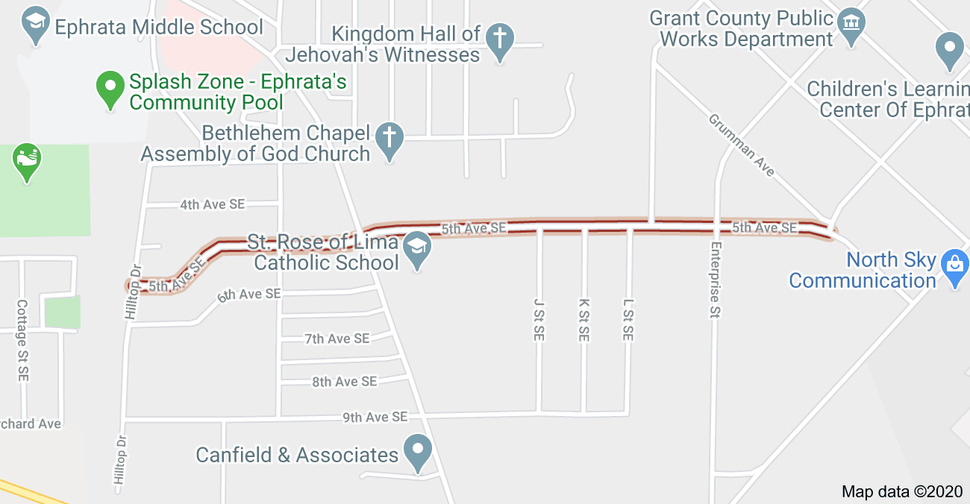

After School Pick up 2:40-3:00 p.m.
- Each family has an assigned numbered parking space and always park in that space for afterschool pick up.
- Cars should enter our front parking lot from Nat Washington and exit on 5th street next to the school. We hope this planned car flow limits safety issues.
- When our staff member sees you in your parking space they contact your student’s teachers and your children are sent to your car.
- Students exit doors closest to classroom.
- Staff members will monitor parking lot for safety.
Bussing (More info on bussing when we get it!)
- Quincy and Moses Lake Bus Chaperones will screen student temperatures and check health screening tickets before parents leave the bus pick up area.
- Ephrata School District health procedures will be followed by students riding ESD buses to school.
Cleaning
- Student Cleaners assigned on Job Chart: desks, chairs, door handles every morning and before dismissal.
- Custodian cleans all surfaces daily.
- Student bathrooms will be wiped down between 1-11, 1-2, and afterschool.
Cohort Scheduling
- K/1/2, 3/4, 5/6: Entry, Recess, Lunch scheduled in cohorts to reduce interaction between groups of students.
- Lunches brought to classroom. Lunch coordinator met with OSPI to adapt Covid procedures.
- Each cohort will have assigned support staff for only that cohort. They will offer specials, monitor lunch and recess.
- PE, Lunch, Music can be outside when possible.
- Classroom lunch monitors so teachers have breaks.
- Whole class bathroom breaks need to be monitored to reduce cross contact between cohorts.
Community Outreach & Staff Training:
- Health Procedures will be posted on our website, and sent out via remind and email.
- It is likely we will become aware of a positive test or case in our school communities before the health authority is notified. When the school’s designated individual becomes aware of a positive case or test, or, close contact by a student or staff to an individual who has tested positive for CoVid, the Diocesan Director of Schools and the local health authority are to be notified as soon as possible. The School will take instruction from the health authority as to whether a portion of or the entire school will need to shift to an Alternative Learning Environment (ALE). Only the Governor, local Health Officer, State Superintendent or District Superintendent have the authority to order this. Should the Health Officer decide not to take action where the Principal believes it necessary, the decision to move to an ALE will be made by the School’s Pastor after consultation with the Bishop and Director of Schools. Please see the attached Covid Daily Screening Action Flow Chart.
- In order to make Contract Tracing by the health authority more efficient, the school will record the names of students sitting at each seat in each classroom they occupy (in the case of a grade that rotates students to different rooms throughout the day). These records will be held a minimum of 14 calendar days.
- Some parents (& possible staff) may choose to keep they child(ren) home in certain conditions, so, we must remain ready to accommodate their needs within reason. In the case of staff refusal to come to the worksite, we will consult Vice Chancellor’s office for instruction on how to proceed.

