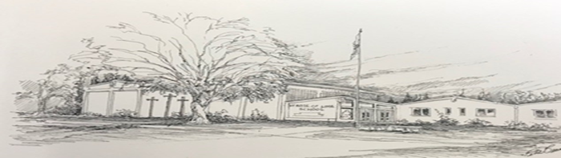
SAINT ROSE OF LIMA CATHOLIC SCHOOL NEWSLETTER 12/3/21
TGIF PAINT & SIP! RUSTICGIRLPAINTING.COM
TGIF PAINT & SIP! FRIDAY, December 3rd at 7:00pm
$39 each. Step by step painting will be taught. Wine provided.
Registration is required for painting.
All are welcome to come gather and visit.
Christmas Program
Thursday, December 16th
7:00 PM
AUCTION PROCUREMENT!
WE NEED YOU TO COLLECT ITEMS TO BE AUCTIONED OFF!
You, and a friend or family member, may have a talent or place to stay that you can donate to the auction. These often make the best auction items. We can also add to your items to make them bigger adventures.
HAVANA NIGHTS AUCTION
SATURDAY
FEBRUARY 26TH!
PDO MEETING
MONDAY, DECEMBER 6TH
6:00 PM
WWW.SAINTROSESCHOOL.ORG
509-754-4901
INFO@SAINTROSESCHOOL.ORG

