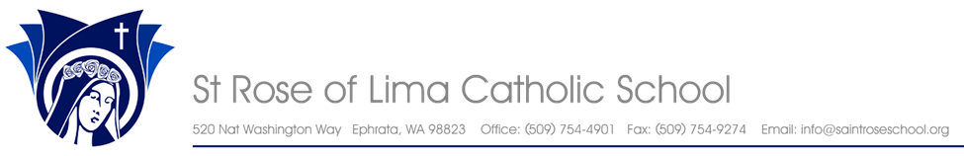
School Vision: St. Rose of Lima Catholic School exist to bring as many souls as possible into the loving arms of Jesus Christ and support their total academic success, regardless of faith background, ethnicity, ability to pay, or home language. School Mission: Christ Inspired, Academic Excellence SLE’s: We are Christ centered. We have inspired faith. We can academically achieve. We choose excellence of character.
St. Rose School Community,
Today, we received the news that a staff member is positive for the Coronavirus. I will soon be sending out a letter from the Health Department. I can tell you the following from my conversation with the Health Department:
1. All St. Rose staff will be quarantined until March 25th.
2. Some of our students will also be quarantined until March 25th and they have been notified.
3. Because of the quarantine, staff will now wait to announce at home learning plans until March 26th.
4. Only those who had close contact with the staff member will be quarantined, not their family members.
5. Watch for symptoms of fever, shortness of breath, and cough. Call your doctor before going to the doctor's office.
You have all been so patient and kind during this situation. I am also in quarantine but will take tech passwords home with me, and work at sharing them with you. I have not left the building yet because I know I can't come back! I suggest students read and practice math facts each day. Students can keep a daily journal about these days away from school. Students can also draw pictures in journals if they are too young to write in them. Older students who have access should get on IXL to practice math, language arts, social studies, and science.
Let us be wise in our choices and put others first. Let us be assured that God is good and in control.

Be Not Afraid,
Stef Bafus, Principal
St. Rose of Lima Catholic School
sbafus@saintroseschool.org

